

**THAKUR POLYTECHNIC**

**Computer Engineering Department**

## SYCO-C SEMESTER - 4 [2023-2024] Group – 29

SUB: **GAD- GUI Based APP.Dvpt (22034)**

1. **Shaurya Tiwari -169**
2. **Kunal Trivedi -170**
3. **Om Upadhyay -171**
4. **Shivangi Upadhyay -172**
5. **Rajas Vartak -173**
6. **Vivek Vijay Pawar-174**

Guided by **Mrs. Pooja Patil**



## MAHARASHTRA STATE BOARD OF TECHNICAL EDUCATION

This is to certify the following group of students roll no. **169-174** of **4th** semester of Diploma in **COMPUTER ENGINEERING** of institute, **THAKUR POLYTECHNIC** (Code: 0522) has completed the **Micro Project** satisfactorily in subject - GAD (22034) for the academic year 2023

– 2024 as prescribed in the curriculum.

**Place:** **Mumbai Enrollment No.: 2205220496-501**

**Date : 3-4-2024** **Seat No.:127082-127088**

**Mrs.Pooja patil Mrs.Vaishali rane Mr.S.M ganechari**

**Subject teacher Head of Department Principal**

**Seal of**

**Institution**

**ACKNOWLEDGEMENT**

Performing our assignment, we had to take the help and guideline of some respected persons, who deserve our greatest gratitude. The completion of this assignment gives us much Pleasure. We would like to show our gratitude to **Mrs. Pooja Patil**, Course Instructor, **Thakur Polytechnic** for giving us a good guideline for assignment throughout numerous consultations. We would also like to expand our deepest gratitude to all those who have directly and indirectly guided us in writing this assignment.

In addition, a thank you to Lecturer **Mrs. Pooja Patil**, who introduced us to the Methodology of work, and whose passion for the “underlying structures” had lasting effect. Many people, especially our classmates and team members, have made valuable comment

suggestions on this proposal which gave us inspiration to improve our assignment. We

thank all the people for their help directly and indirectly to complete our assignment.

# PROPOSAL

**PROPOSAL**

**Title : ENROLLMENT SYSTEM**

### AIM OF THE MICRO PROJECT:

Micro-Project can also help students to develop skills specific to

collaborative efforts, allowing students to tackle more complex problems then they could do on their own

* Delegate roles and responsibilities.
* Analyze the collected data and generate a enrollment system from it.
* To develop additional skills integral to the future, such as critical thinking and time management.

### COURSE OUTCOMES:

* + Understanding of Software devlopment
  + Data management Skills
  + User Interface design
  + Software development proficiency
  + Project management skills

1. **ACTION PLAN:**

|  |  |  |  |  |
| --- | --- | --- | --- | --- |
| **Sr No.** | **Details of activity** | **Planned start date** | **Planned finish date** | **Name of Responsible Team Members** |
| 1. | Information Research | 7-3-24 | 9-3-24 | Vivek vijay pawar  Shivangi upadhyay |
| 2. | Group Discussion | 7-3-24 | 11-3-24 | Vivek vijay pawar  Shivangi Upadhyay  Rajas Vartak  Kunal Trivedi  Om upadhyay |
| 3. | Taking Reference | 11-3-24 | 18-3-24 | Vivek vijay pawar  Rajas vartak |
| 4. | Executions | 18-3-24 | 21-3-24 | Kunal Trivedi  Om upadhyay |
| 5. | Compilation of reports | 21-3-24 | 27-3-24 | Vivek vijay pawar  Shivangi Upadhyay |
| 6. | Presentation and Report  submission | 27-3-24 | 27-3-24 | Kunal Trivedi  Om upadyay |

1. **RESOURCES REQUIRED:**

|  |  |  |  |  |
| --- | --- | --- | --- | --- |
| **Sr No.** | **Name of resources** | **Specifications** | **Quantity** | **Remarks** |
| 1. | Google Chrome | Search Engine | 1 | Available |
| 2. | Microsoft Word | Ms. Office 2019 | 1 | Available |
| 3. | Computer System | Intel i3 6006U 8GB RAM | 1 | Available |

|  |  |
| --- | --- |
| **Roll Numbers of the Team Members** | **Names of the Team Members** |
| **169** | **Tiwari Shaurya Dilip** |
| **170** | **Trivedi Kunal Alpesh** |
| **171** | **Upadhyay Om Jitendra** |
| **172** | **Upadhyay Shivangi Chetan** |
| **173** | **Vartak Rajas Nitin** |
| **174** | **Vivek Vijay Pawar** |

**Mrs. Pooja Patil (Subject Teacher)**

# REPORT

**Report**

**Title : ENROLLMENT SYSTEM**

### RATIONALE:

A Enrollment system helps in organizing and managing vast amounts of data related to students, faculty, courses, finances, and facilities. This centralized database improves data accuracy, accessibility, and security.

* + Automation of routine administrative tasks such as admissions, enrollment, attendance tracking, grading, scheduling, and fee management saves time and reduces manual errors. This allows

administrative staff to focus on more strategic activities.

* + A enrollment system facilitates communication between various stakeholders including students, faculty, administrators, and parents. Features like messaging, notifications, and announcements ensure effective communication, fostering collaboration and engagement.

### AIMS/BENEFITS OF THE MICRO PROJECT

* + Streamline administrative task
  + Enchancing communication
  + Improving data management skills
  + Enhancing student experience

### COURSE OUTCOMES ACHIEVED:

* + Understanding of Enrollment system
  + Data management Skills
  + Software development proficiency
  + Project management skill

1. LITERATURE REVIEW:

Enrollment system would typically explore various aspects related to the implementation, usage, challenges, and benefits of such systems. Here's a structured overview of what

such a literature review might include Trace the historical development of college

management systems, from traditional paper-based methods to modern digital platforms Discuss the emergence of computerized systems and the transition to web-based and

cloud-based solutions

1. **Introduction:**

Enrollment system facilitates the effective management of student data, including admissions, enrollment, personal details, academic records,

attendance, and disciplinary history. supports the planning, scheduling, and management of academic activities such as course management, curriculum

design, class scheduling, examination management, and grading. CMS enables the management of faculty and staff data, including recruitment, payroll,

attendance tracking, performance evaluation, and professional development.

1. **program code:**

**Imports System**

**Module EnrollmentSystem**

**' Define a Student class to store student information Class Student**

**Public Property ID As Integer Public Property Name As String Public Property Age As Integer**

**Public Property GradeLevel As Integer**

**' Constructor to initialize student properties**

**Public Sub New(id As Integer, name As String, age As Integer, gradeLevel As Integer)**

**Me.ID = id Me.Name = name Me.Age = age**

**Me.GradeLevel = gradeLevel End Sub**

**End Class**

**' Define the EnrollmentSystem class to manage enrollment operations Class EnrollmentSystem**

**Private Students As New List(Of Student)()**

**' Method to enroll a new student**

**Public Sub EnrollStudent(student As Student) Students.Add(student)**

**Console.WriteLine("Student enrolled successfully.")**

**End Sub**

**' Method to display all enrolled students Public Sub DisplayEnrolledStudents()**

**Console.WriteLine("Enrolled Students:") For Each student As Student In Students**

**Console.WriteLine($"ID: {student.ID}, Name: {student.Name}, Age:**

**{student.Age}, Grade Level: {student.GradeLevel}") Next**

**End Sub End Class**

**Sub Main()**

**Dim enrollmentSystem As New EnrollmentSystem()**

**' Example usage: Enrolling students enrollmentSystem.EnrollStudent(New Student(1, "John Doe", 18, 12))**

**enrollmentSystem.EnrollStudent(New Student(2, "Jane Smith", 17, 11))**

**enrollmentSystem.EnrollStudent(New Student(3, "Alice Johnson", 16, 10))**

**' Example usage: Displaying enrolled students enrollmentSystem.DisplayEnrolledStudents()**

**Console.ReadLine() ' Keep the console window open End Sub**

**End Module**

### OUTPUT:

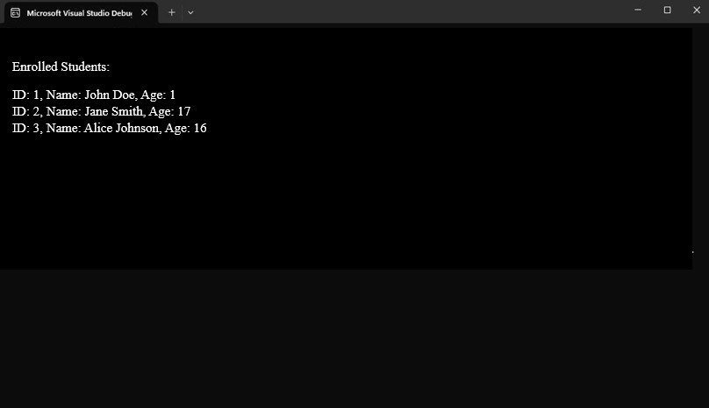

1. **CONCLUTION;**

Enrollment system represents a pivotal tool for modern educational institutions, offering a

centralized platform to streamline administrative and academic processes. Through this system, colleges and universities can effectively manage various aspects of their operations, including student information, academic programs, faculty management, financial transactions, and

communication channels

1. **ACTUAL RESOURCES USED:**

|  |  |  |  |  |
| --- | --- | --- | --- | --- |
| **Sr No.** | **Name of resources** | **Specifications** | **Quantity** | **Remarks** |
| 1. | Google Chrome | Search Engine | 1 | Available |
| 2. | Microsoft Word | Ms. Office 2019 | 1 | Available |
| 3. | Computer System | Intel i3 6006U 8GB RAM | 1 | Available |

### SKILLS DEVELOPED/LEARNING OUT OF THE MICRO PROJECT:

* + Managing the financial resources of the college involves budgeting,

financial planning, revenue generation, expenditure control, fundraising, procurement, accounting, and financial reporting.

* + Human resource management focuses on creating a supportive and productive work environment, promoting professional development
  + promoting professional development, ensuring compliance with labor laws and regulations, and fostering a culture of inclusivity, diversity, and equity.

### APPLICATIONS OF THE MICRO PROJECT:

* + A enrolment system helps in organizing and managing vast amounts of data related

to students, faculty, courses, finances, and facilities. This centralized database improves data accuracy, accessibility, and security.

* + Automation of routine administrative tasks such as admissions, enrollment, attendance tracking, grading, scheduling, and fee management saves time and reduces manual

errors. This allows administrative staff to focus on more strategic activities.

* + A CMS facilitates communication between various stakeholders including students, faculty, administrators, and parents. Features like messaging, notifications, and

announcements ensure effective communication, fostering collaboration and engagement.

MRS.POOJA PATIL

(Subject Teacher)